Week 2 - Creating Pickups

**Section 1 – Creating a new C++ class**

In the Editor select “Add New” then from the drop down select “New C++ Class” 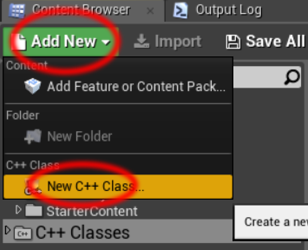

Select “Actor” then press “Next”

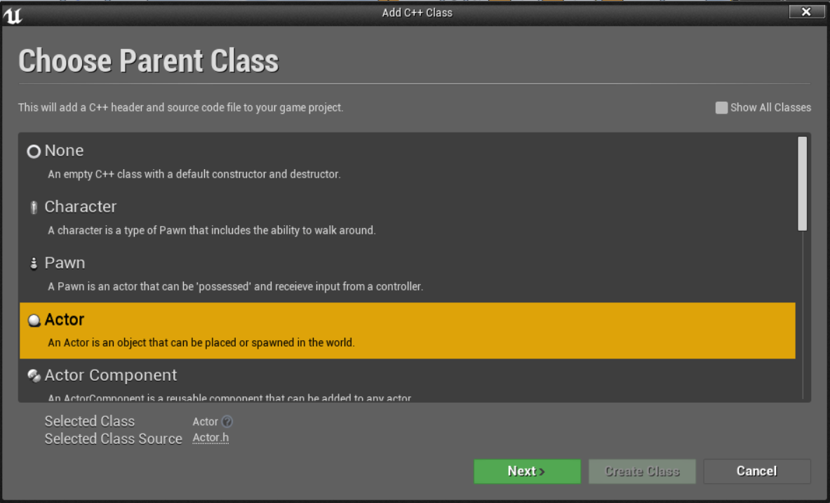

Name the class “PickupBase” make sure the path ends in “/Public/” then press “Create Class”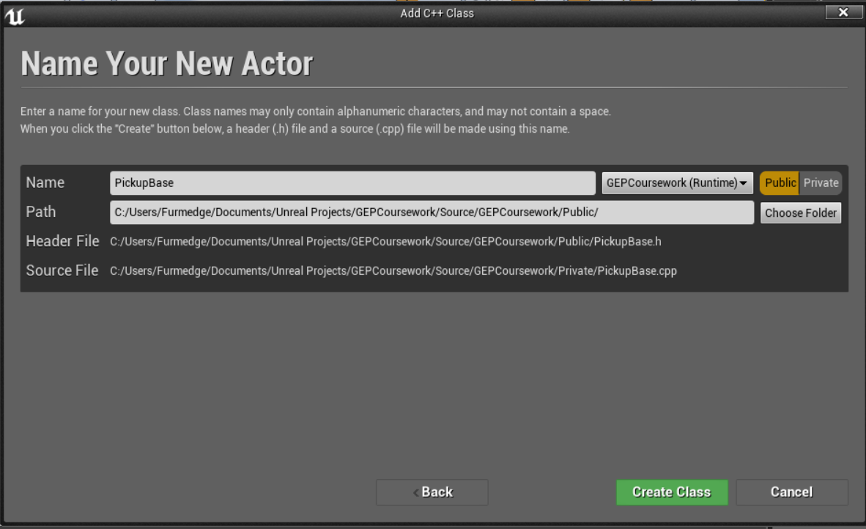

1.In the header file define a protected USphereComponent, this will be our collider. Don’t forget to forward declare class USphereComponent;

UPROPERTY(VisibleAnywhere, Category = "Components")

USphereComponent* SphereComp;

2.In the constructor in the .cpp create the sphere component, make sure to also include "Components/SphereComponent.h"

SphereComp = CreateDefaultSubobject<USphereComponent>(TEXT("SphereComp"));

3.Back in the header add these two public function declarations

void NotifyActorBeginOverlap(AActor * OtherActor);

UFUNCTION(BlueprintImplementableEvent, Category = "Pickup")

void OnActivate(AActor* pickedUpBy);

*NotifyActorBeginOverlap is an overridden Actor function that is called when a collision occurs, similar to OnCollisionEnter in Unity.*

*OnActivate is going to be an event we expose to blueprint, designers can then create functionality extending from this node.*

4.In the .cpp create the implementation of NotifyActorBeginOverlap, it should call OnActivate. Do not create implementation for OnActivate, this is handled in blueprint only.

void APickupBase::NotifyActorBeginOverlap(AActor * OtherActor)

{

OnActivate(OtherActor);

}

5.Compile then open up the editor.

**Section 2 – Blueprint Implementation**

1. Add a new blueprint class and derive it from PickupBase, Name it “PickupHealth”

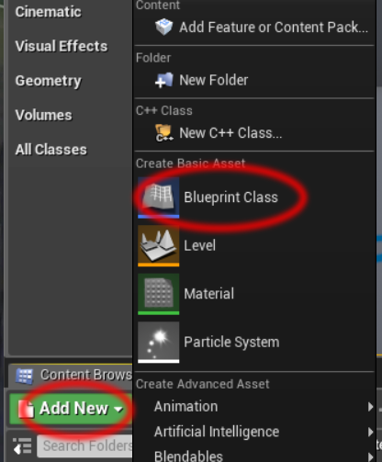 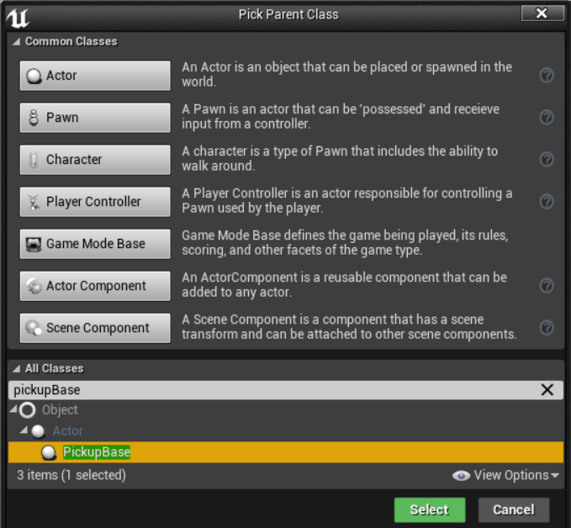

2.Open up the full blueprint editor for PickupHealth, select SphereComp and untick “Hidden In Game”, as there is no mesh this allows us to see something in game.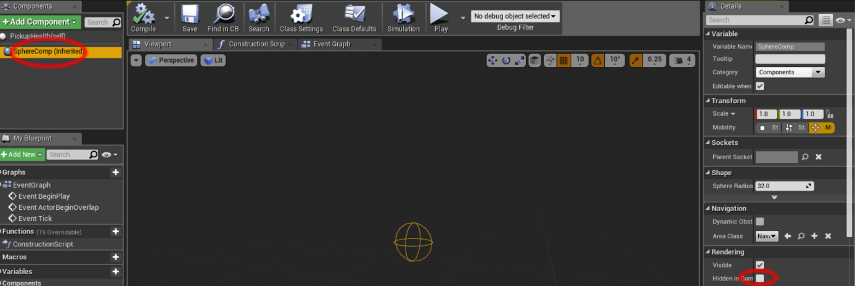

3.Open the Event Graph and delete the default nodes (OnTick etc.)

4.Create an OnActivate node and hook it up like this:

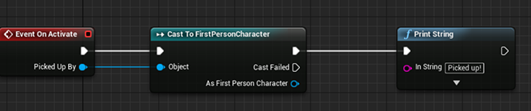

5.Drag a Pickup Health blueprint from the content browser into the scene and press play.

When you walk over it a message should appear in the top left.

**Section 3 – Player Health**

1. Open up the FirstPersonCharacter blueprint
2. Create a new variable by pressing the + symbol next to “Variables” (bottom left)
3. Name it Health and set it as type float
4. Compile then set the default value to 100
5. Create a new custom event by right clicking empty space then searching “Add Custom Event”
6. Name it Heal and add an input by selecting the event node then pressing the + symbol next to “Inputs” in its details panel on the right, make it type float can call it “Heal Amount”
7. Set up the rest of the implementation so you end up with something like this:

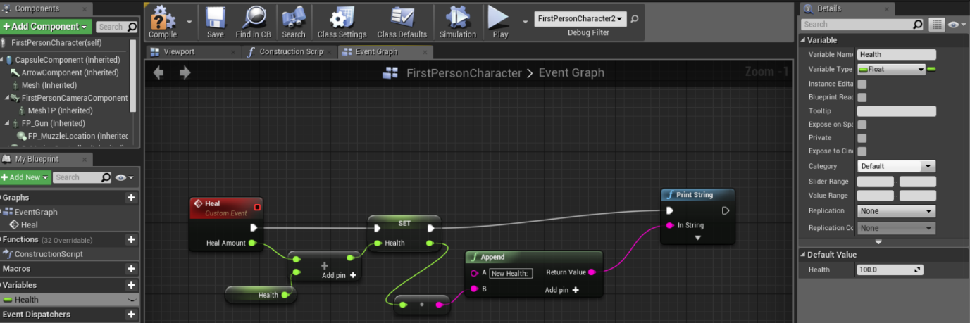

**Challenges**

1. When you collide with a pickup call the Heal Event on the colliding character
2. Allow the designer to change the amount that the healing pickup heals. *\*Hint* set variable to instance editable*
3. Add a suitable mesh to the pickup
4. Create another pickup that damages the player instead
5. Create a pickup that increases the players movement speed for 10 seconds
6. *Optional* Create IHasHealth interface as demonstrated. If stuck see documentation or ask me for help

https://docs.unrealengine.com/latest/INT/Engine/Blueprints/UserGuide/Types/Interface/